Birla Institute of Technology & Science, Pilani
Work Integrated Learning Programmes Division
Second Semester 2023-2024

Mid-Semester Test
(EC-2 Regular)

Course No. : SE ZG503
Course Title : Full Stack Application Development
Nature of Exam : Closed Book
Weightage : 30%
No. of Pages = 3

No. of Questions = 6
Duration : 2 Hours
Date of Exam : 17/03/2024 (FN)
Note to Students:
- Please follow all the Instructions to Candidates given on the cover page of the answer book.
- All parts of a question should be answered consecutively. Each answer should start from a fresh page.
- Assumptions made if any, should be stated clearly at the beginning of your answer.

- Design a set of RESTful APIs for a mobile app that helps users find nearby restaurants for food delivery or dine-in. The app should provide autocomplete suggestions as users type in their search queries, allow them to search for restaurants based on various criteria, view detailed information about individual restaurants, and read reviews before making a decision.
Below are the detailed requirements
1. Autocomplete Search:
- Users should receive autocomplete suggestions as they type in the search box.
- Autocomplete suggestions should be based on the partial search term entered by the user.
2. Restaurant Search:
- Users should be able to search for restaurants based on keywords.
- The search should take into account the user's current location.
- Users should have the option to filter restaurants based on delivery availability.
3. Restaurant Details:
- Users should be able to view detailed information about a specific restaurant.
- Information should include the restaurant's name, address, delivery availability, and rating.

Design the following API endpoints: [3*3=9 Marks]
- Autocomplete Search
- Restaurant Search
- Restaurant Details
For each API endpoint, Specify the purpose and the exact URL, Identify the supported HTTP operation, define required and optional parameters with examples, and describe the structure of the response along with the appropriate status code with an example output.

- The image below is a waterfall view from the Chrome developer tools of a webpage. Analyze the snapshot given and answer the following questions [5 Marks]

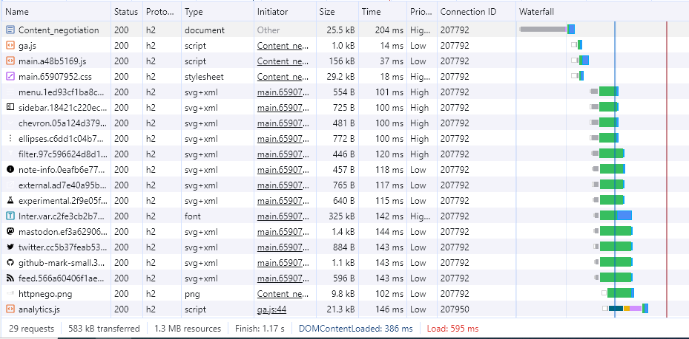

The below image shows the time taken for the first request (content negotiation)
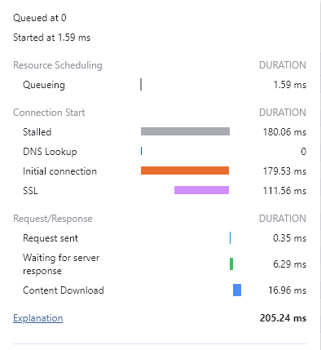
- Which version of HTTP does the website use, and what is the number of request-response cycles?
- Does the webpage reuse the TCP connection for multiple requests? Justify your answer.
- What is the significance of TTFB(Time to First byte), and what is the value of TTFB for the first request?
- What does it mean if long blue sections(Content download) are present in the waterfall view of the request, and how can it be reduced?
- How much time does the webpage take to complete HTML Parsing?

  - A frontend react app polls the backend REST API every five minutes to check for changes in the user database. Instead, I want the backend to detect a change in the database and automatically send that updated information to the React app.
Can I use Webhooks to implement this scenario? Suggest a solution to implement this scenario. [3 Marks]

  - HTTP/1.x sometimes results in a slow page load and poor user experience. Does the HTTP/2 resolve this problem, and how? [4 Marks]

  - What challenges are associated with cross-platform app development, and how can they be mitigated? [3 Marks]

  - [3*2=6 Marks]
- How does the "ETag" header work in HTTP caching, and what role does it play in cache validation?
- What response/s should the REST API send in the case of a failed content negotiation, where the client and server cannot agree on a mutually acceptable representation format?
- In what scenarios will the API send a 204 No content status code?

*****

